Rhyme and Reason

Evaluation
October 2025

Contents
Introduction 3
Executive Summary 4
Methodology 5
Evaluation against aims and outcomes 6
How can poetry support young people’s mental health and emotional well-being? 6
Was the modified Arts for the Blues model effective in schools? 7
What impact did the program have on young people, teachers, artists, and schools 10
Impact for young people in detail 10
Impact for teachers, artists and schools 12
Recommendations and actions 14
Conclusion 16
Appendix 1 17
Key differences between Arts for the Blues in therapy context and in schools context. 17
Arts for the Blues: Clinical vs. School Contexts – Continuities and Adaptations 19
Appendix 2 21
Project Theory of Change 21
Appendix 3 23
Example Poem 23

Introduction
The Rhyme and Reason project set out to explore how poetry can be used to support the mental health and emotional well-being of young people in secondary schools in the north-west of England. The program responded to a growing crisis in youth mental health, intensified by the pandemic, cost of living pressures, and academic stress.
Rhyme and Reason is an adaptation of a model called Arts for the Blues that was developed by Edge Hill University and the University of Salford. It is an evidence-based creative psychotherapy model for depression, low mood, and anxiety. The model uses various art forms such as visual art, music, and movement, within a structured yet flexible framework, in clinical settings. Edge Hill University offers training professional therapists to learn and implement this model within their own practice to improve mental health outcomes.
By adapting the Arts for the Blues model for use in schools, the project aimed to:
1. Support KS3/KS4 for students' well-being through poetry.
2. Test how Arts for the Blues could be modified for classroom delivery.
3. Develop the creative health skills of teachers and Teaching Artists (poets).
4. Strengthen partnerships between schools and Teaching Artists to support sustainable creative health practice.
The differences and similarities between the clinical model and schools-based model are mapped out in Appendix 1.
Over 12 months, five schools, five Teaching Artists (early to mid-career poets), and one poet mentor, participated in co-designed residencies. This report synthesizes practitioner reflections, student outcomes, and evaluation observations to assess the project’s effectiveness against its aims.

Executive Summary
The evaluation found strong evidence that poetry enhances students’ emotional expression, confidence, and engagement. Creative scaffolding and consistent relationships were key to success.
Practitioners valued the opportunity to develop skills in creative health and reflective practice, though some challenges emerged in adopting the Arts for the Blues model to school environments. Longer sessions, stronger links to well-being priorities, and clarity of purpose were recommended for future delivery.
The project demonstrated that poetry is a powerful tool for creative health when delivered collaboratively, flexibly, and with care.
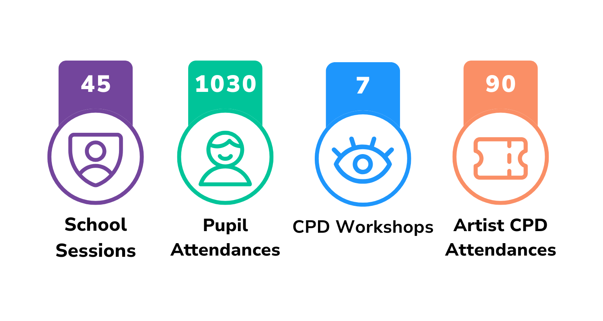

Methodology
This evaluation used a qualitative, mixed methods approach, grounded in principles of action research and reflective practice. It draws on the collective experiences of teachers, Teaching Artists (poet practitioners), and students to understand the impact of poetry-based interventions on mental health and emotional well-being.
Data sources included:
- facilitator and teacher reflections from in-person evaluation sessions;
- student feedback (verbal and written) during and after sessions;
- creative outputs (e.g. poems, group poems, and visual metaphor);
- practitioner evaluations of individual residencies;
- case examples and anecdotal evidence of change;
- ‘Washing up’ focus group discussion with participating teachers and Teaching Artists;
- informal observation and documented changes in engagement, confidence, and emotional expression.

The evaluation focused on outcomes set out in the project theory of change (Appendix 2) and
included:

- engagement and enjoyment of poetry
- emotional literacy and self-expression
- relationships in group dynamics
- confidence and resilience
- appropriateness and adaptability of the Arts for the Blues model in a school context
- professional development of teachers and artists.

The evaluation prioritised qualitative data, and a psychology pilot study was undertaken via Goldsmiths University of London, to explore the use of standardised metrics specifically in relation to young people's emotional well-being and creativity: results of this study are pending.

Evaluation against aims and outcomes

How can poetry support young people’s mental health and emotional well-being?
Positive outcomes were observed, including:
Students demonstrated increased emotional expression, confidence, and engagement
“Confidence built: students entered a national poetry competition.”

High rates of reported well-being benefits (e.g. 95% of one school cohort felt better able to cope with stress)

Creative tools for engagement (the use of metaphors, free writing, and visual prompts) enabled emotional processing and connection between peers.
“They felt able to express powerful feelings.”

Case examples:
- Students who had previously disengaged, wrote personal, emotive poetry and actively participated in sharing and performance.
- Students voluntarily took poems home to share with families or posted them around school.

One Teaching Artist undertook before and after survey questionnaires with his class and said:

“I think the biggest impact you can see in the stats really. The fact that 100% of the students said they hated poetry at the start of the project to now 71% saying they like poetry is quite a stark contrast. The fact that the students feel more comfortable talking about subjects like mental health and their confidence growing is a huge achievement.”

Was the modified Arts for the Blues model effective in schools?
Findings:
The model provided a helpful structure but required adaptation.
“… we’ve got so many things outside of our control, it’s more the environment that’s the problem, not so much the students or the model, or the practitioners at all.”

Challenges included:
- Delivery in a classroom setting rather than a therapeutic space.
- Young people taking part are attending as part of their statutory curriculum, rather than having been referred or self-selecting as in a clinical setting.
- Mental health and wellbeing was not communicated to young people as the specific focus of sessions.
- Young people had different levels of emotional literacy; sometimes not having the language to talk about emotions when prompted.
- Larger groups (25 to 30 students) versus those found in a clinical setting (smaller groups of 10) made a significant difference. There was some discussion about trust and acceptance within the group dynamic too.
- Delivery was fragmented due to school timetables, two-week rotations, and half term holidays. Artists had around 50 minutes per session per week.
- Practitioners suggested delivering longer sessions of a few days or using the model with identified vulnerable groups for greater depth. (however, would move away from the whole class within curriculum time model we were testing)
- Practitioners felt that they would have liked to see more of the Arts for the Blues team rather than just one introductory training session. The content of the session focused more on creative engagement ideas rather than the science and theory of the model: “As much as this model has been great, I don’t know what the point of Arts for the Blues was.”
Of the training day, Teaching Artists reflected:
“I came away from that day, a bit, I wanted a bit more about the structure. I felt like a lot of it was lovely ways of doing creative things”.

“In an Arts for the Blues session where they are doing it properly, the student, the people within that group, would probably not have walked straight in from a corridor of 100 kids barging past to go and get to chemistry and a water bottle being thrown from the third floor and being shouted at by the nearest teacher because you’re not fast enough. It’s a gorgeous model and I’m really open to delivering something like that. I think it’s beautiful, but I’m not convinced it’s right for this project in schools.”

“It’s a very good template. I feel like we’re still going to achieve what we wanted to achieve over the 10 weeks but the template has to really be adapted.”

What practitioners told us in more detail:
During the evaluation day both teachers and poets talked about the factors that influenced the extent to which their sessions were successful. Those factors included the structures within school for example:
- Consistency of student attendance. In one school in year nine there is a cycle which means that every six weeks new students join the class. This meant that the class started off small and then it grew. This had an effect upon how safe and trusting and bonded the group felt when creating responses related to their emotions.
- Time of day. There was broad agreement that sessions taking place in the morning were much more successful and engaging for people than those in the afternoon.
- Group dynamics. There was some discussion in our evaluation session about the influence of personalities in the classroom for example (references were made to ‘Alpha boys’). On reflection, practitioners felt they would try to mix the groups up much more in future.
- Creative engagement. Metaphor tasks like selecting a postcard image to represent feelings, or choosing a sticker to show feelings, were described as surprisingly successful.
- Structures and scaffolding. The group agreed that when writing with a scaffold, for example by offering first lines or first words, and giving the young people something concrete to build upon, that’s when they came out with “brilliant, metaphorical stuff that they never would have, on their own, because they wouldn’t have freed their minds up like that.”
- Year group. Practitioners considered which year group this sort of intervention works best with. They suggested that year sevens would not be their preferred group in future unless the project was placed much later in the year. This related to the amount of time pupils had been at the school, and the fact that relationships had not yet formed between pupils. “I think that they didn’t trust, they didn’t have the relationship, whereas in year 10 they did.”
- Curriculum versus extra-curricular. Practitioners talked about the curriculum which is ‘forever tightening’ and considered whether running the sessions after school as an extra-curricular project might be a way forward. Other practitioners pushed back arguing that the project was important for all young people rather than those who would self-select to attend an extracurricular club. This related to the efficacy of the intervention in supporting mental health and well-being.
- Classroom environment. Practitioners talked about how the setting for the sessions affected how the young people responded. Interestingly, the sessions were more successful when people sat at desks than when they were in an open drama space. The practitioners described this as a turning point.

“If we were able to deliver this gorgeous project over 2-4 days for example, so fit our 10 hours into two full days, and still be in the space, still have your mind in that model, so the students have their mind in that too, I think it would work significantly better.”

“I took a risk on it, because we’ve got BTEC Performing Arts and our deadlines are massive. For me personally, I think the emotional… and just that sense of their own self-worth… the emotional support that they’ve got from this project has been massive. Some of my students wouldn’t even take a speaking role, and are now saying, ‘yeah, I’m gonna do that’.”

Key differences between clinical and school setting

The differences and continuities between Arts for the Blues in the clinical setting and its adaptation for the classroom setting are mapped out in Appendix 1.
In the clinical setting, Arts for the Blues is a twelve-week programme with sessions lasting several hours, using a range of arts approaches with self-selecting, clinically referred participants.
Its adaptation for a whole-class approach in schools had therapeutic and preventative aims; meeting young people ‘where they are at’ and giving them creative wellbeing ‘tools’ that they could use in future.

“I do think the Arts for the Blues model was Ok, however, I do feel what we achieved with these groups of students would have been achieved anyway over 10 weeks, regardless of the model. It was nice to have maybe a little bit of structure to it, but I think as a practice it wasn’t the right setting for it. On the evaluation day we talked about how we could use it on maybe kids who are facing exclusion from school, or constantly in detention, or behavioral issues. Seeing if there’s any meaningful improvement on some of those young people.”

“The project provided encouragement, connection and play for students who expressed that they found school stressful and dysregulating. It provided a small pocket of rest and ease, with students often telling us this was ‘their best lesson of the day’. “

“… the model provided a clear and practical framework that guided the planning and delivery of each session. Its structure helped balance creativity with emotional safety, giving pupils a consistent space to express themselves whilst maintaining a sense of progression and trust.”

What impact did the program have on young people, teachers, artists, and schools
Young people:
- Developed skills in poetry, creative thinking, emotional literacy, and teamwork.
- Greater self-confidence and openness about mental health.
- Increased enjoyment and ownership of learning.

“A key breakthrough was seeing a participant who initially did not appear to like writing, becoming inspired enough to write a poem he was proud of and enter it into a competition. Another memorable moment was when a selective mute pupil began laughing and smiling during a game, showing a real shift in confidence.”

Impact for young people in detail
- Confidence and voice
Students grew in self-belief and were proud of their creative expression.
Reluctant writers found their voice, culminating in performances and competition entries.
Many reported feeling more confident speaking about feelings and opinions.
“Confidence and voice to be and accept feelings.”
“Reading their poems out loud, pride in their published group poems.”

- Emotional expression and mental health.
Poetry was used as a safe outlet to express complex emotions (grief, depression, anxiety).
Students talked openly about friends, family, and their inner experiences.
“Sharing their experience of living with depression.” ”Writing an ode to a close relative who had died… Expressing how they feel about them.” (The young person went on to read the poem at the funeral.)

- Connection and relationships
Friendships were formed: empathy between peers and emotional sharing increased.
Poetry became a medium for connection, with classmates, staff, and family.
“Telling the whole group how they feel about their friend.”
“Students wanted to share poems with certain members of staff.”

- Engagement and motivation
Students were enthusiastic, showed increased attendance, and looked forward to sessions.
There was a visible shift in classroom atmosphere, energy, and participation.
“Excited for poet to come in… disappointed when not in.”
“Lots more laughter during the session and in regular lessons.”

- Ownership and agency
Students made personal choices to take their work home or share it more widely.
They were suppored to facilitate and shape the creative space, showing pride and initiative.
“Can I take my poetry book home?”
“Students wrote personal poems… put around school.”

- Recognition and inclusion.
The project gave quieter or overlooked students a chance to shine.
Staff noted how it created space for positive recognition and praise.
“A chance to praise those students who don’t always hear it.”
“All students engaged… even those who sat out came back in.”

Teachers:
- Confidence in creative facilitation and evaluation
- New partnerships and skills development in evaluation and adaptation.

Artists:
- Understanding of school environments and creative health practice.
- New partnerships and skills development in evaluation and adaptation.

“This experience has fundamentally shaped my practice. I now naturally integrate sensory and visual tools into my workshops, making them more accessible and inclusive. The project has also given me a deeper understanding of how poetry can support wellbeing, which I will carry forward into future collaborations.”

Schools:
- Reported increased willingness to embedded arts based approaches in wellbeing work
- Recognise the value of poetic expression for whole class inclusion.

Impact for teachers, artists and schools
Teachers and poets reflected together on what they will take away from this project. Their feedback is captured under the following headings:
Knowledge
- Great composition, timing, and environment significantly influence outcomes.
- Not all students or school leaders are invested in the art or creative approaches.
- Evaluation is valuable but needs clearer purpose and alignment with project aims.
- Understanding students as individuals is key, some may lack visible confidence.
- Facilitation style (e.g. using visual prompts) impacts on engagement.
- Classroom setting and time of day affect emotional openness and focus.
- Some school policies may inadvertently undermine well-being work.
- Arts for the Blues is most effective when adapted by schools to their context.
- Regular reflection and checking in with aims, help helps to maintain focus.
- Voice is a vital driver of engagement on ownership.
Understanding/attitudes.
- Stepping outside the curriculum creates meaningful space for emotions and learning.
- Freedom and playfulness were energising for both students and staff.
- Underestimated students often flourished when given creative freedom.
- Valued the time to connect, share ideas, and reflect.
- Pride in students’ creative breakthroughs was a powerful motivator.
- Teachers appreciated structured opportunities for collaboration and creation.
- Poetry enabled emotional connection and communication beyond standard teaching.
- Residential and planning phases built strong relationships and foundations.
- Students were seen differently as a result of the project.
Skills
- Planning and managing long-term creative projects in schools (especially for early career poets).
- Adapting sessions responsibly to group needs and dynamics.
- Scaffold, structures, and genres to support poetry writing.
- Facilitating diverse poetic forms (e.g. blackout poetry, odes).
- Encouraging creative risk-taking and emotional expression.
- Conducting effective check-in and formative evaluations.
- Leading reflective and student centred creative practice.
- Building on the resources provided by Tom (poet) and his workshop approaches.
Legacy
- Retain and share writing frames, scaffolded exercises, and check-in tools.
- Use creative evaluation techniques as data and tools for feedback.
- Strengthen final outcomes planning (e.g. clear final session/closure).
- Creativity is a valid source of insight into students well-being (e.g. poems on anxiety/depression).
- Advocate for whole school support and buy in.
- Apply the transferable facilitation and planning skills to wider context.
For next time
- Avoid copy and pasting workshops; tailor them to the group.
- Don’t give students total autonomy, some structure is essential.
- Not all evaluation methods suit group, adapt accordingly.
- Rethink assumptions about needing large or special spaces, classrooms often work better.
- Change session timings or format if engagement dips.
- School staff roles and expectations regarding well-being, poetry, and evaluation.
- Avoid overloading the project with competing or unclear purposes, streamline where possible.

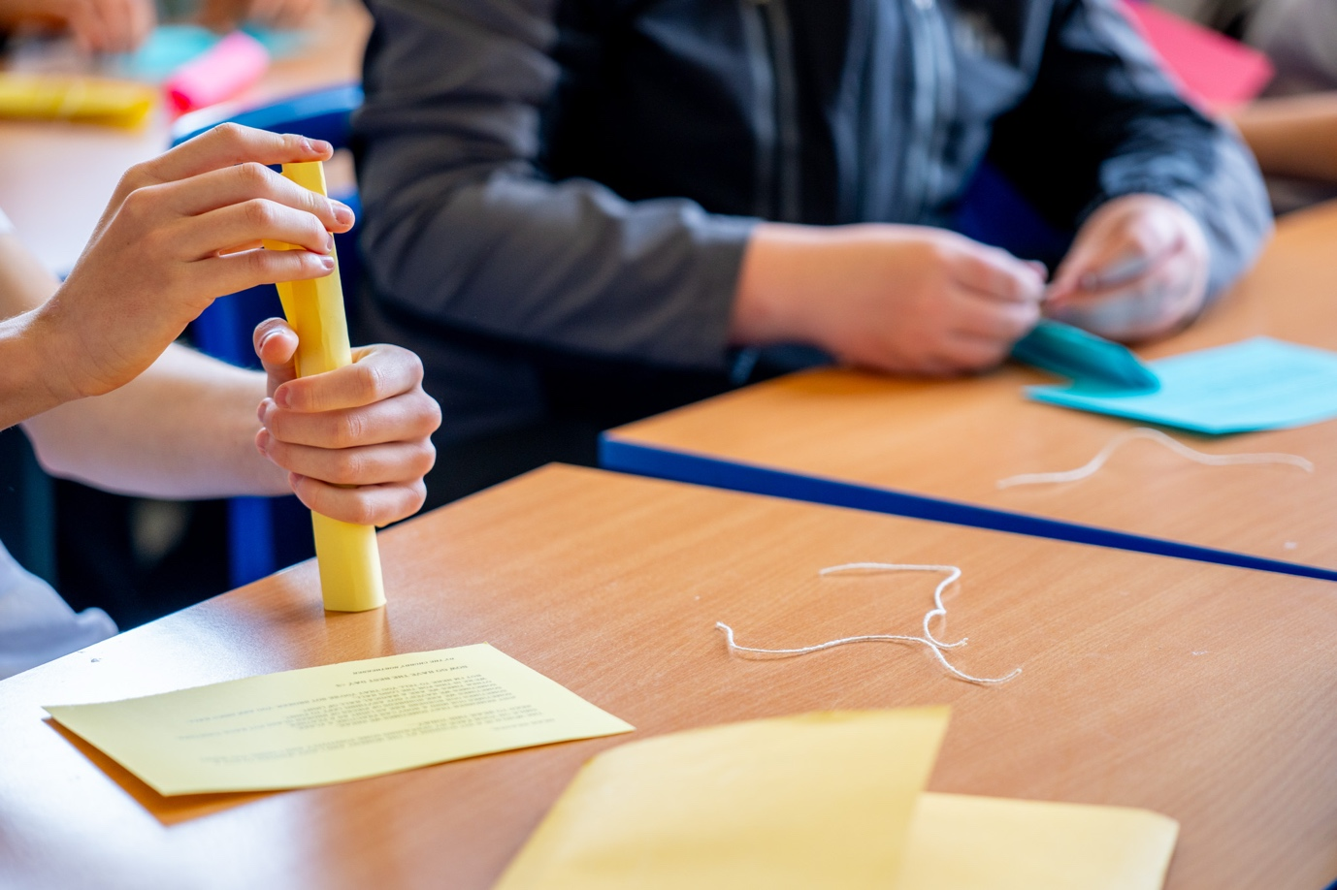

Recommendations and actions
As Rhyme and Reason moves into a second iteration throughout the academic year 2025-2025, the team makes the following recommendations and is taking the following actions in light of the year 1 evaluation:

1. Deepen the Adaptation of the Arts for the Blues Model
Recommendation: continue refining the model for school context in collaboration with Edge Hill University and The University of Salford we are redesigning the training and support to deepen the poets and teachers understanding of the Arts for the Blues model and the mechanisms for change as well as focusing on creative wellbeing rather than clinical aims
Actions:
- Embedding discussion of the AFB model within the supervision sessions
- Develop a ‘schools toolkit’ outlining how the eight Arts for the Blues ingredients map onto classroom practice
- Provide differentiated versions of the model for whole-class delivery and small-group targeted interventions
- Integrate trauma-informed and safeguarding principles explicitly into the revised framework

2. Strengthen Training and Professional Development
Recommendation: Ensure facilitators understand both the creative and psychological foundations of the model.
Actions:
- Redesign practitioner CPD to include theory behind Arts for the Blues and its application in education the AFB training to focus more on the model and the underlying research and less on delivery activities
- Facilitate joint training sessions for Teaching Artists, teachers, and mental health leads to build shared understanding.
- Pair early-career poets with mentors for reflective practice support thoughout delivery.

3. Improve Project Design and Delivery Logistics
Recommendation: Structure delivery for continuity, depth, and emotional safety.
Actions:
- Consider testing some extracurricular sessions where pupils can self-refer
- Schedule session in morning where possible to maximise engagement
- Prioritise consistent pupil-groups to build trust and belonging

4. Clarify Project Framing and Communication
Recommendation: Strengthen how schools, teachers, and pupils understand the purpose of the project.
Actions:
- Frame Rhyme and Reason as a creative wellbeing and literacy project rather than a ‘mental health intervention’
- Curious Minds, teacher and poets co create an introduction of the wellbeing measurement
- Align project messaging with school wellbeing and PSHE priorities.

5. Enhance Evaluation and Evidence Building
Recommendation: Continue developing mixed-method approaches to capture change in wellbeing, confidence, and engagement
Actions:
- Use a recognised Wellbeing Measure in all the settings
- Use shared reflection tools across sites for compatibility
- Integrate Goldsmith data into the evaluation Framework and results from Goldsmith's pilot study once available, to strengthen evidence of impact.

6. Build Sustainable School-Artist Partnerships
Recommendation: Embed poetry and creative wellbeing practice in school culture.
Actions:
- Support schools to integrate creative wellbeing into their curriculum or enrichment plans.
- Develop teacher-led poetry wellbeing resources for classroom use.

Conclusion
The Rhyme and Reason project demonstrated that poetry can be a powerful tool for promoting mental health and well-being in schools. It enabled emotional expression, strength and relationships, and boosted confidence among young people, especially when supported by strong school artist collaboration.
However, adaptation of the Arts for the Blues model proved necessary. It is most effective when flexibly delivered, with attention to the classroom setting, the duration of the sessions, and the dynamics of the class group.
Key insights for future practice:
- Scaffolding creative writing boosts accessibility for young people and achieves better outcomes.
- The success of the project depends on the buy-in of teachers, the logistics within the school, and a whole school understanding of creative health.
- Young people benefit most when emotional expression is integrated playfully and supported with a safe environment

“This was a very special project. The training and preparation was very thorough and it was hugely beneficial to build the relationships with the group as a whole and our individual teacher(s) prior to the start. The opportunity to work with the Curious Minds team, our teachers and supporting artists, and other poets in a creative, critically reflective and empathetic way, set a tone for the whole project. There was a real sense of care given to the project.”
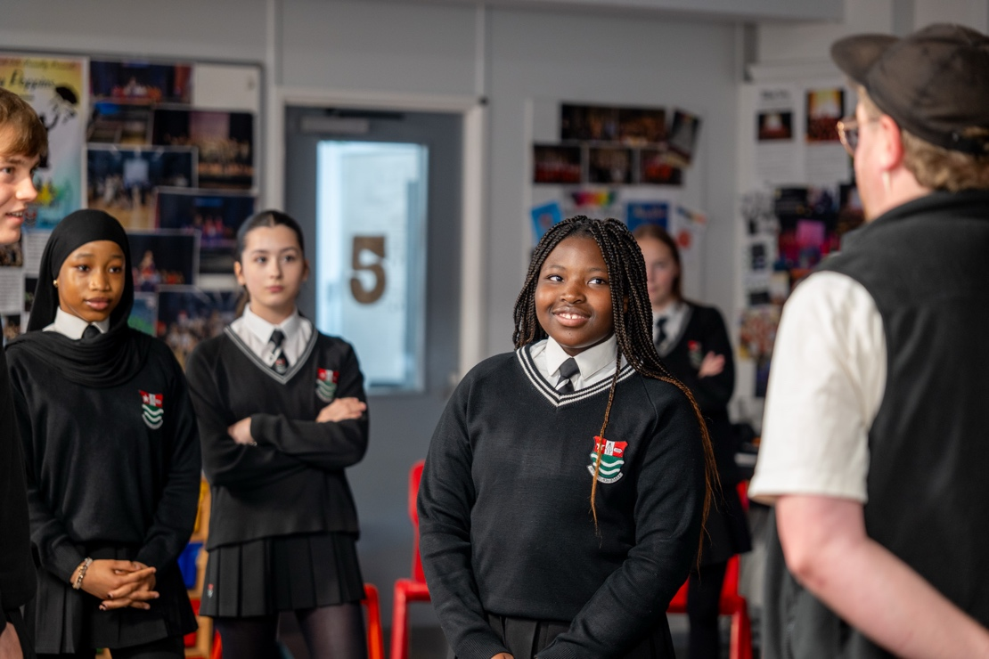

Appendix 1

Key differences between Arts for the Blues in therapy context and in schools context.

Dimension | Clinical/ Therapy Context | Secondary School / Curriculum Context
Primary aim | Improve mental health and wellbeing outcomes through arts-based psychotherapeutic intervention | Support emotional literacy, self-expression and resilience within a creative learning framework
Core Purpose | Treatment and recovery addressing symptoms of depression, anxiety, trauma or distress. | Prevention and early intervention. Promoting wellbeing and belonging, enhancing creative and social learning.
Setting & Framing | Delivered within NHS or mental health services, framed as therapy sessions. | Delivered in classrooms (could be offered in enrichment or PSHE/Arts curriculum) framed as creative wellbeing education.
Participant Relationship | Therapist-client relationship with clear boundaries, confidentiality, and clinical supervision. | Teacher-student or facilitator-learning relationship, within school safeguarding and pastoral frameworks.
Session Design | Structured 6-12 week therapy group using evidence-based creative exercises targeting specific emotional needs. | Adaptable schemes of work or shorter sessions embedded in arts, PSHE, or wellbeing curricula.
Group Size and Format | Small groups (typically 6-8) to ensure psychological safety and depth. | Whole class groups (approx 30) designed for accessibility, inclusion and engagement.
Ethical& Safeguarding Framework | Governed by HCPC/BACP codes of ethics, data protection for therapy notes, clinical governance. | Governed by school safeguarding policies, teacher standards, and child protection protocols.
Evaluation Focus | Measured change in clinical outcomes (e.g. mood, anxiety, self-esteem, wellbeing scales) | Measured change in educational and developmental outcomes (e.g. confidence, self-expression, peer relationships, creative skills)
Language & Framing | Uses therapeutic language e.g. ‘clients’, ‘sessions’, ‘treatment’, ‘emotional processing’. | Uses educational / wellbeing language e.g. ‘pupils’, ‘workshops’, ‘creative expression’, ‘self awareness’.
Duration and Frequency | Typically weekly for 60-90 minutes over a defined therapeutic period. | Can be integrated flexibly, e.g. single sessions, half-term or termly projects.
Partnership | Often delivered in collaboration with NHS Trusts, mental health charities, or university research teams. | Delivered through school-arts partnerships, with CPD for teachers, and co-delivery with Teaching Artists.
Intended Impact | Reduced mental health symptoms, improved coping mechanisms, enhanced sense of agency. | Improved classroom climate, creative confidence, emotional awareness, and wellbeing literacy.
Theoretical Foundations | Rooted in arts psychotherapies and evidence-based mental-health models. | Rooted in arts-education, creative pedagogy, and whole-school approaches to wellbeing

Arts for the Blues: Clinical vs. School Contexts – Continuities and Adaptations

Dimension | Shared Principles (Core to Arts for the Blues) | Clinical Therapy Context | Secondary School / Curriculum Context
Foundational Aim | Use creative processes to support emotional expression, connection, and meaning-making. | Focused on mental health treatement and recovery. | Focused on wellbeing education, inclusion, and emotional growth.
Theoretical Roots | Grounded in embodied, relational, creative, and meaning-making approaches; integrates neuroscience, psychology, and arts practice. | Draws explicitly from arts psychotherapies (e.g. drama, dance, art therapy). | Draws from arts education, social-emotional learning, and creative pedagogy.
Mechanisms of Change | Emotional expression, creativity, play, connection, reflection, movement, imagination, and empowerment. | Used to help clients process trauma or emotional distress. | Used to help pupils explore and regulate emotions, build empathy, and develop confidence.
Structure & Delivery | Cyclical journey through eight key ingredients (e.g. play, embodiment, emotional expression, reflection) | Delivered as a structured therapeutic group process with clinical goals. | Adapted into lesson plans, creative sessions, or wellbeing projects aligned with curriculum aims.
Facilitator Approach | Co-created, compassionate, non-judgemental, embodied, creative. | Therapist-client relationship; clinical supervision and confidentiality. | Teacher/artist-pupil relationship; classroom boundaries and pastoral care.
Group Process | Focus on belonging, trust, and shared creativity. | Small, closed groups to ensure psychological safety. | Can operate in larger groups; classroom norms and peer support provide safety.
Art Forms Used | Multi-arts (movement, drama, music, visual arts, writing). | Arts used to access and transform emotion safely. | Arts used to stimulate expression, creativity, and collective wellbeing.
Framing Language | Creativity as a route to wellbeing and human connection. | Framed as therapy (clinical intervention) | Framed as learning (wellbeing and creative education)
Emotional Focus | Exploration and regulation of emotion through creative means. | Deep processing and integration of emotion, potentially addressing trauma. | Naming and normalising feelings; developing emotional literacy and coping tools.
Outcomes | Empowerment, connection, and self-awarness through creative engagement. | Measured in mental health outcomes (e.g. mood, distress, wellbeing scales) | Measured in educational and wellbeing outcomes (e.g. confidence, empathy, engagement).
Ethical Holding | Safety, respect, confidentiality, and boundaries. | Clinical ethics and supervision structures. | Safeguarding and educational ethics within school systems.
Evaluation Focus | Evidence-based impact on wellbeing through creative process. | Quantiative and qualitative data on clinical change. | Mixed methods assessing wellbeing, participation, and creative engagement.

Appendix 2

Project Theory of Change

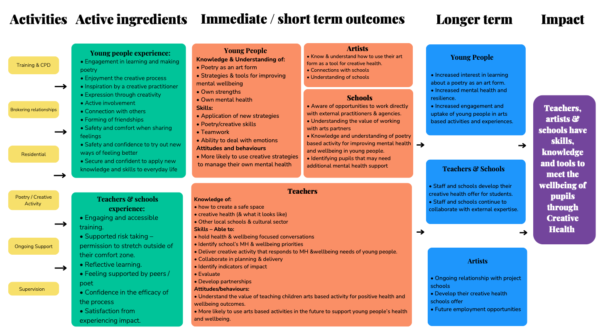

Appendix 3

Example Poem
Be yourself!
Be proud of who you are,
Accept and embrace your unique differences.

Be confident in yourself.
In your work!
Be positive about your achievements.
Deserve them.

Be yourself!
You don’t have to be happy all of the time.

Don’t worry too much about the opinions of others and what they think,
They are irrelevant to you.
Ignore the people who judge you!

Be who you want to be.
You’re pretty inside and out!
Try to be kind to everyone,
If you don’t like them.
Be nice to everyone,
Even if they don’t reciprocate.
It’s nice to be nice!

Be yourself!
You won’t regret it!
Choose what you want to be,
do the things that you want to do.
And don’t let anyone tell you,
Right or wrong about it.
Who you want to like
Without anyone telling you who you ‘should’ like

Be confident and be yourself!
Try not to care about things that are outside of your control.
Don’t rely on others too much.
Try not to be too emotionally attached to the thoughts of people that hurt you.
Don’t listen to people who are nasty to you,
And don’t let rumours ruin your peace!
So just be yourself!
Speak out when you need help.
About the future, not the past
Be brave!
Amazing!
Be you!

Be!
With massive thanks to Curious Minds for employing me to deliver this work as part of the Rhyme and Reason project, Dr Saul Spray, Miss Thompson, Miss and Miss for their support and belief in the power of creativity and words and year 10 for their participation and their contributions. Your poem offers excellent advice!
Participants: Ray, Daniella, Ebony, Sophia, Cheyenne, Connor, Erin, Millie, Kaci, Lily E, Luke, Jessica, Jayden, Bethany, Mia, Lilly O, Lillie T, Brooke, phoebe, Ayeshia, Bethany, Leona, Alexie, Fritz

